Toolbox
P
Clustering

Category:  Methods for Groupwork  Tags:  Number of people:  Abstract:  Method of creative writing with underlying star structureOrt:  Hilfsmittel:  - Paper and pens |  | Source:  https://iak-talente.de/werkzeuge/techniken/clustering/
 |  | Time (hours):
 |  | Evaluation:
Description | Basic rules  1. the cluster begins with the cluster core: a single word or phrase is written down in the middle of a sheet and a circle is drawn around this beginning.  2. associations are now noted starting from the core. Each association is circled again and connected to the previous association by a line.  3. a new chain of associations starts again at the cluster core.  4. each association is noted. A censorship does not take place.  The creation of a cluster is quickly explained:  Write a keyword (topic) in the middle of a large sheet of paper and from this middle form chains of ideas (free associations). As soon as a chain is finished (because you can't think of anything else), you go back to the middle and start a new chain of thoughts, for the same keyword.  The mind map needs much more explanation. There is a whole set of rules (its inventor Tony Buzan even talks about laws) that the user has to follow if it is to become a real mind map, e.g:  Use lines of varying thickness for the branches, which become thinner and thinner as the distance from the core word increases. Write the next keywords on these strokes, towards the center with larger letters, and at a greater distance from it with smaller letters. Use colours. Use pictures, especially for the center. And so on and so on.  Free association  In our opinion, the concept of free association, which is very important, comes second in Tony Buzan's work and without the very decisive addition . Accordingly, one experiences the cluster, in which the most spontaneous (free) association possible plays an essential role, much more liberating and creative - but also more wild and sometimes even confusing.  A mind map is constructed much more thoughtfully. Yes: built - or constructed - is the right word.  Accordingly, we like to use clustering at the beginning of a creative process and the mind map in the second phase, when it comes to organizing the ideas (from the cluster) and planning, i.e. translating them into a practical result (for example, the draft of a novel).  From cluster to mind-chain-organization  Instead of just working with keywords (as in this example and as Gabriele Rico suggests), you can also write half or whole sentences or even small parts of sentences in the individual thought bubbles. In this way you not only get a collection of material and structure (= the individual branches), but even a kind of raw text. You only have to type the latter, extend and change it a little bit - and you have a real raw text that you can continue working with. We call this extended version of clustering Thought Chain Organization  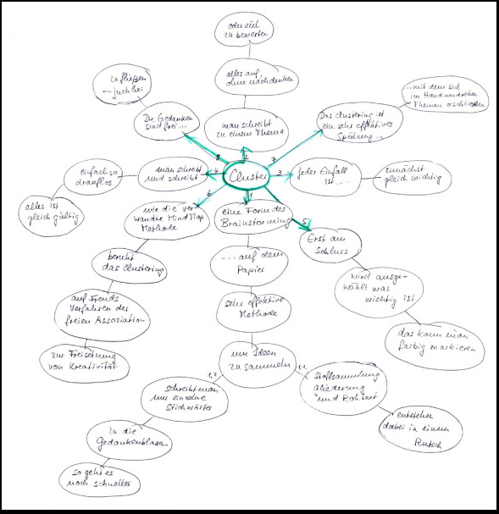  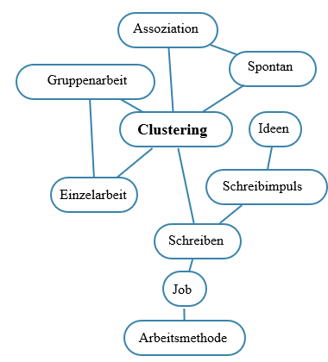  Von MScharwies - Eigenes Werk, CC BY-SA 4.0, https://commons.wikimedia.org/w/index.php?curid=65422032
Preparation |  | Notes:
Goal |  | Notes:

